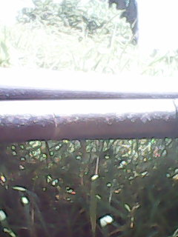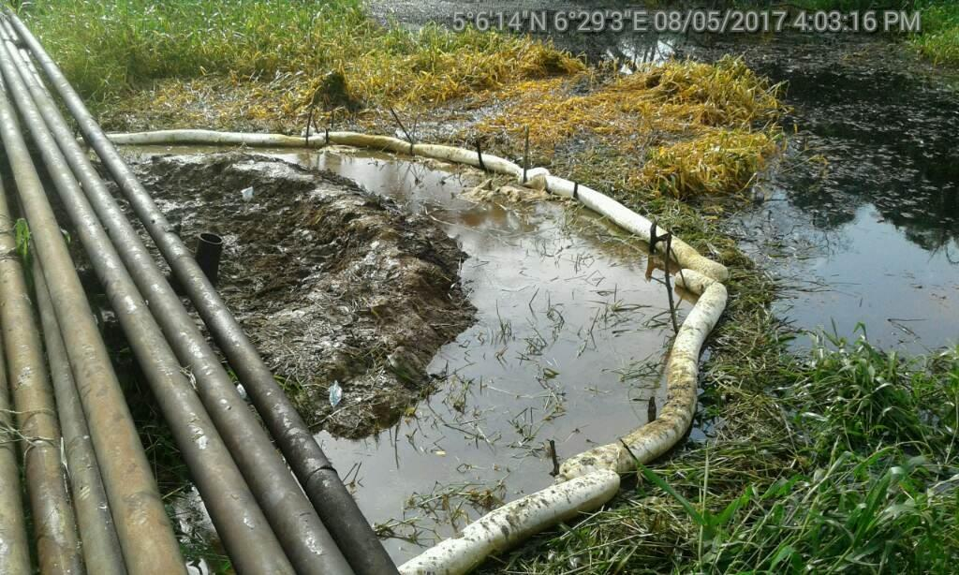

130mm Hack Saw cut on the 4” flow line The absorbent booms put in place for containment
@ 6-11 0’clock position. to avoid further spread of the spill.

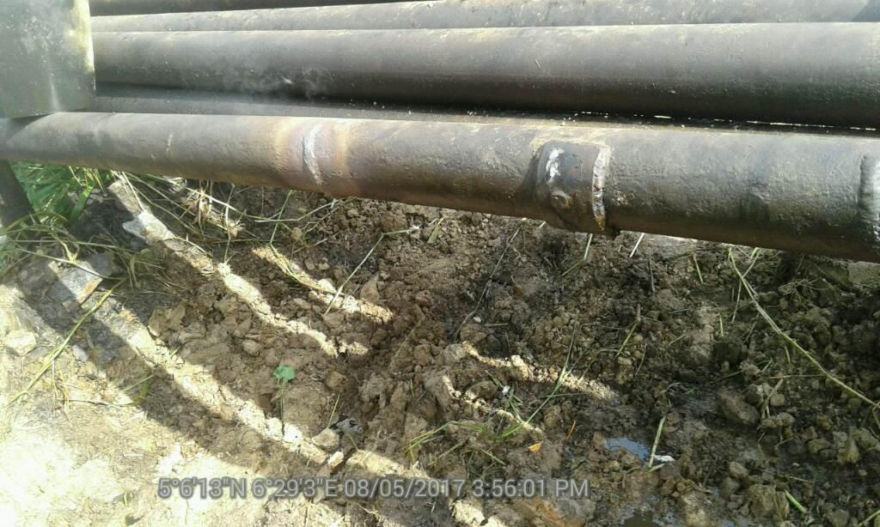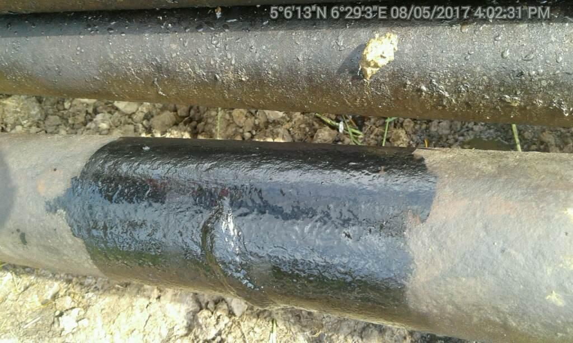

Repaired facility by the respond team

